**Part 2: Texturing**

**Non-Textured**

Castle: Front View

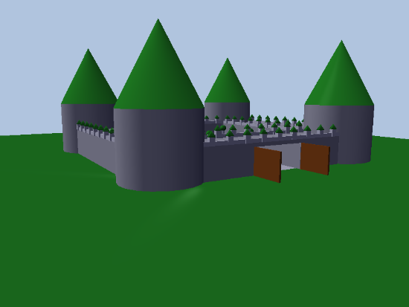

Castle: Top View

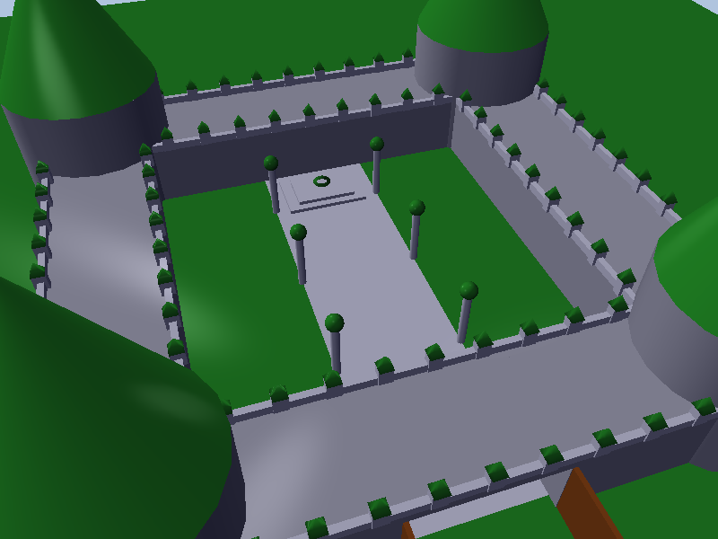

Castle: Inside View

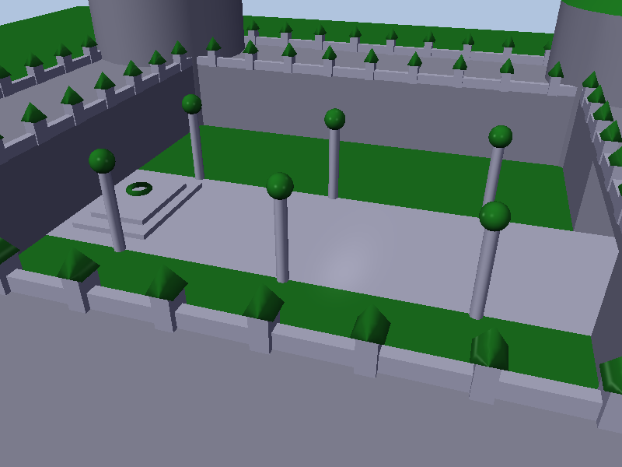

**Materials Used**:

Grass - **Terrain**

Tile – **Path** inside castle and **maze floor**

Metal – **Cylinder Pole** inside castle

Glass – **Sphere** on top of light pole for light source

Stone – **Podium steps** holding Torus at the back of the castle. **Rails & Pyramids** on castle walls.

Ice – **Torus** placed at the back of the castle

Wood –**Cones** on the towers. **Gates** at entrance.

Brick – Main **Castle** **Cylinder Towers & Walls.** **Maze Walls**

Trees – **Tree** textures placed around the castle

**Textured**

Castle: Side View

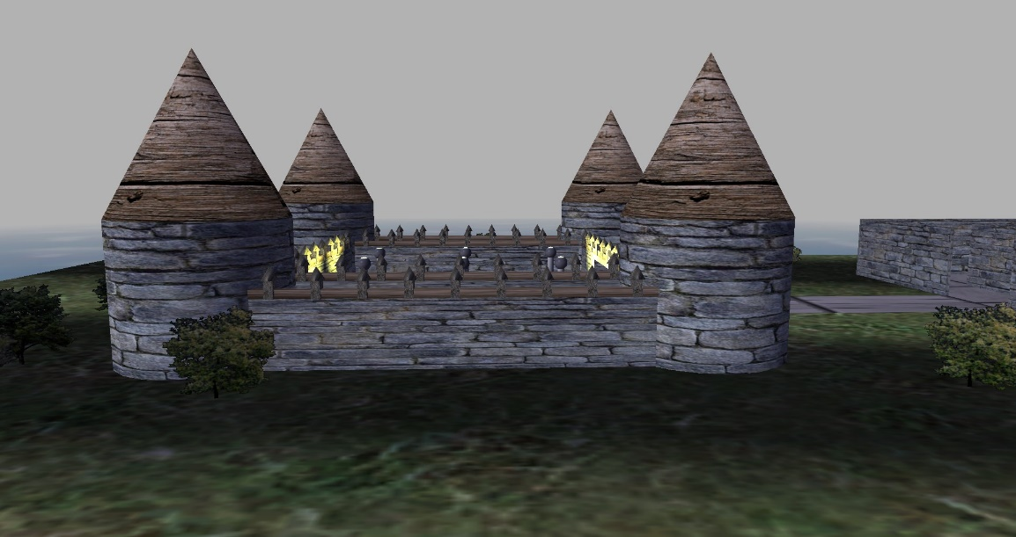

Castle: Front View

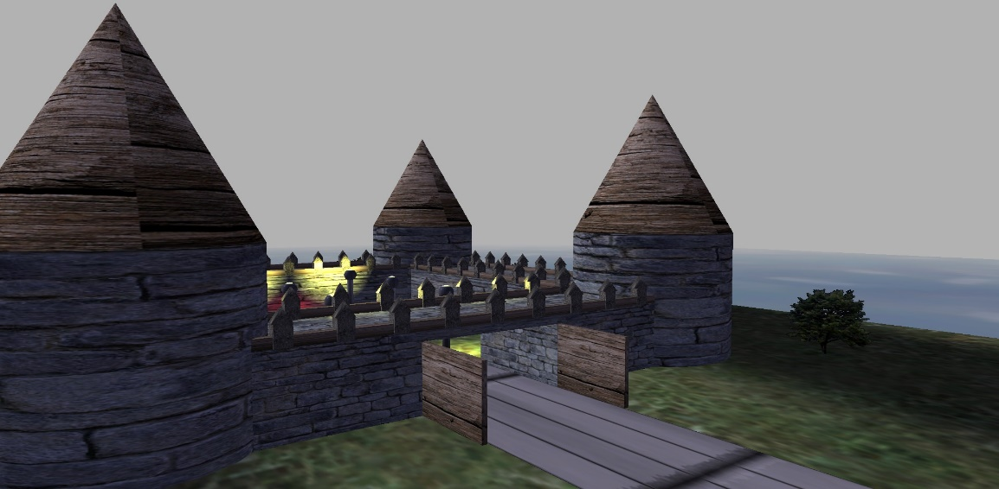

Castle: Inside View

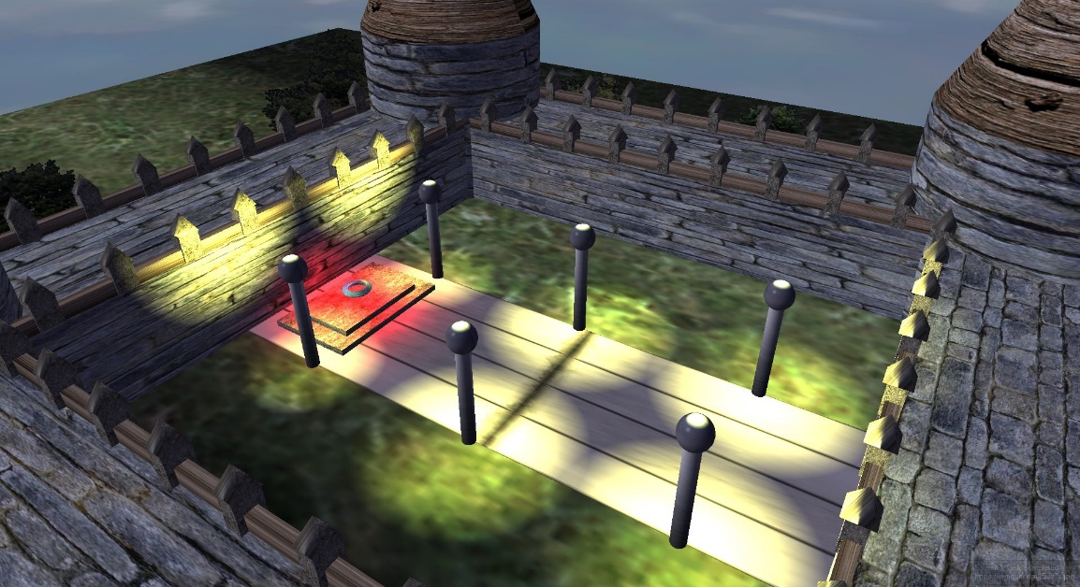

Castle: Top-Down Inside view 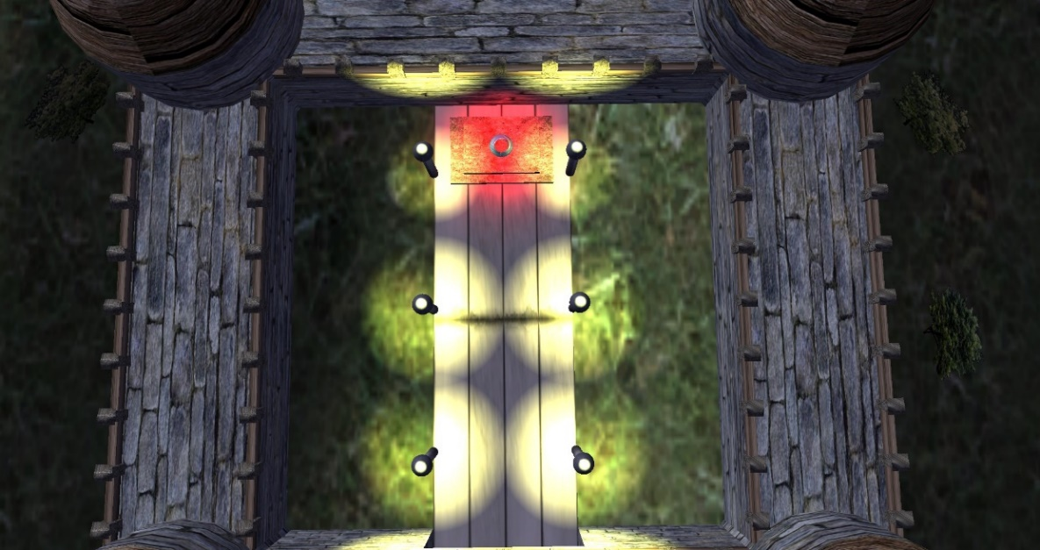

Maze Inside View

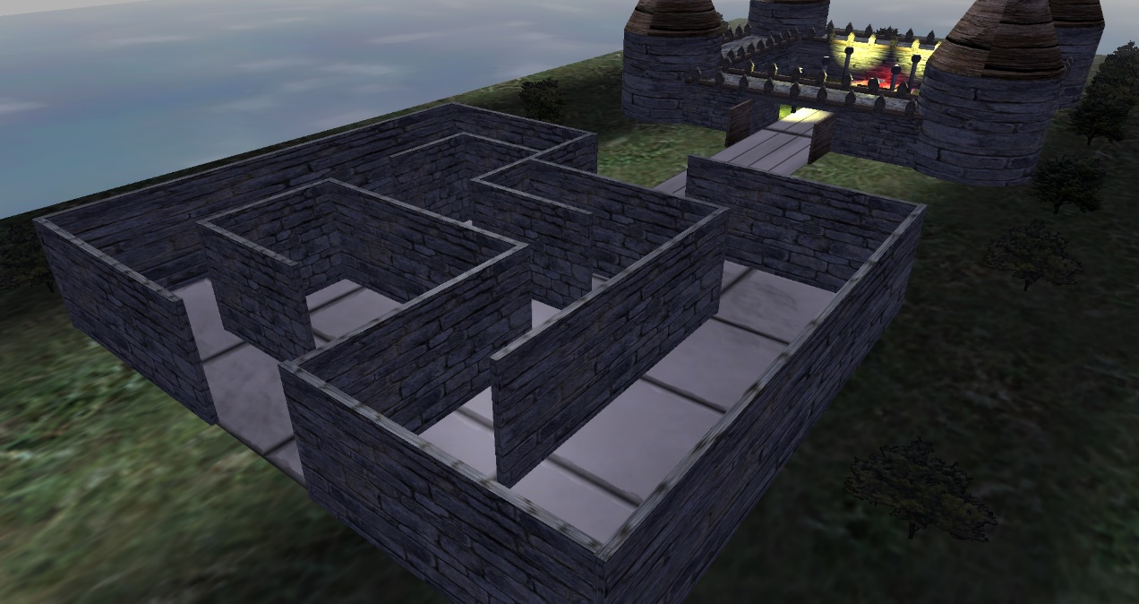

Top-down Maze View

